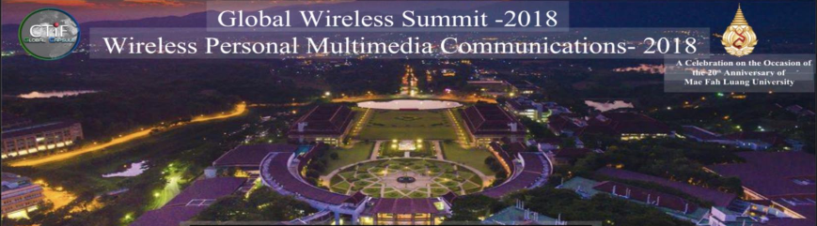
November 25 – 28, 2018 – Chiang Rai, Thailand
Special Session proposal
Title of Special Session
Special Session Organizers
Organizer1, address1/affiliation1, phone1, e-mail1
Organizer2, address2/affiliation2, phone2, e-mail2
(add more organizers if needed)
Aim:

(describe in 1-2 paragraphs – 150 words – the aim of the session)

This special session will be focusing on (but not limited to) the following topics:

- (enumerate a list of specific topics the SS would deal with)

Name of the Track the Special Session fits in:

Tentative titles of at least 5 contributions:

Title1
Author1-1, address1-1/affiliation1-1, email1-1
Author1-2, address1-2/affiliation1-2, email1-2

Title2
Author2-1, address2-1/affiliation2-1, email2-1
Author2-2, address2-2/affiliation2-2, email2-2

Title3
Author3-1, address3-1/affiliation3-1, email3-1
Author3-2, address3-2/affiliation3-2, email3-2

Title4
Author4-1, address4-1/affiliation4-1, email4-1
Author4-2, address4-2/affiliation4-2, email4-2

Title5
Author4-1, address4-1/affiliation4-1, email4-1
Author4-2, address4-2/affiliation4-2, email4-2

(add more papers if needed)

